NAME
SUBJECT | BASIC TECHNOLOGY | CLASS | JSS 3 | DURATION | 2 HOURS

SECTION B: BASIC TECHNOLOGY
- Economic activities in technology includes the following EXCEPT ______
- transportation
- product distribution
- food preservation
- communication
- Workshop hazards can be prevented by ______
- giving first aid
- avoid use of machines
- obeying safety rules
- working very well
- Which of the following is NOT part of electric circuit?
- Magnet
- Cell
- Voltmeter
- Variable resistor
- Which of the following is NOT used as roofing materials?
A. Zinc
B. Grass
C. Asbestos
D. Cotton
- The properties of a metal to crack easily is known as
  - hardness
  - toughness
  - brittleness
  - strenght
- In technical drawing the inclined lines at 45⁰ , 60⁰ and 30⁰ are drawn using
  - frnch curve
  - Tee square only
  - Tee square and set squares
  - templates
- A platform on which woodworkers perform operation is known as _______
  - Bench vice
  - Work bench
  - Machine vice
  - Work table
- The tool used for cutting external thread is called
  - tap
  - hacksaw
  - chisel
  - twist drill
- First aid record book is used for the following EXCEPT the recording of the
  - Information of the victim
  - Scores of the victim
  - Nature of wound
  - Type of treatment giving
- Which of the following isNOT used in rescue operation?
  - Digger
  - Shovel
  - Whistle
  - Trowel
- Which of these metal is used for making cutting tools?
- High carbon steel
- Mild steel
- Cast iron
- Aluminium
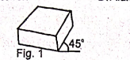
- The object shown in the figure below is drawn in _________

  - perspective
  - oblique
  - isometric
  - orthographic

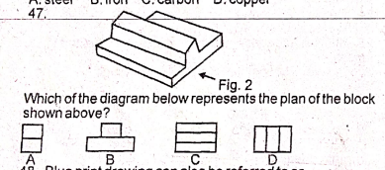
Which of the diagram below represents the plan of the block shown above?
- Which of the following joint is used to construct simple woodwork box?
  - Butt joint
  - Tongue and grove joint
  - tongue and groove joint
  - halving joint
- A file without handle should not be used in the workshop because it
  - will not file well
  - can pierce the hand
  - Will affect the work
  - May cause breakage
- Which of the following is NOT a permanent way of joining metals?
  - Bolt and nut
  - Brazing
  - Riveting
  - Soldering
- The following professionals can work in oil and gas company EXCEPT ____
  - Mechanical engineer
  - Petroleum engineer
  - Aeronautic engineer
  - Safety engineer
- The type of drawing which shows the interior parts of an object is known as ____
- Orthographic drawing
- Pictorial drawing
- Sectional drawing
- Perspective drawing
- Site preparation include the following EXCEPT
  - Uprooting of trees
  - levelling
  - moulding blocks
  - removal of existing structure
- The diagram below represents a/an.........

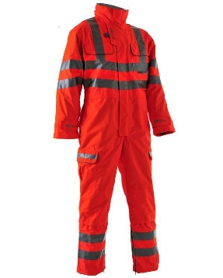
  - Safety boot
  - Overall
  - Sport wear
  - garment

- Which of the following symbols represents a resistor?
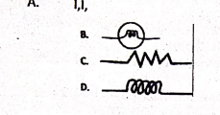
- Cutting grove and slot in metals can be carried out with
  - Grinding machine
  - Lathe machine
  - harmonic motion
  - reciprocating motion
- Which of these is NOT recommended for the maintenance of electric fan?
  - Wipe off dust with soft cloth
  - Clean the motor with soapy water
  - Use fan according to instructional manual
  - Remove stain with soft cloth and soapy water
- The voltage supply for single face in Nigeria is.
  - 110V 60Hz
  - 240v, 50Hz
  - 320v, 60Hz
  - 450V, 50Hz
- Synthetic rubber is made from _______
- inorganic materials
- latex
- rubber tree
- elastic

